Technical Specification
I-001 KUBI File-MBO Interface
Document Status: | DRAFT | REVISION | FINAL

Modification History/Revision Log:
Version | Date | Author | Approver | Remarks
1.0 | 15 Otc 2012 | Zhang, Hua |  | Initial

Table of Content

1. Program Description 3
1.1. Technical Overview 3
1.2. Development Class 3
1.3. Logical Database table 3
1.4. Authorization Group 3
1.5. Frequency 3
1.6. Dependencies 3
1.7. Technical Flow Diagram 3
1.8. Data Processing and Transformations 3
1.9. Screen Layout 3
1.10. Report Layout 3
1.11. Exception Handling 3
2. Development object 4
3. Data Dictionary Modification 4
3.1. List of New/Changed Data Dictionary Objects 4
3.2. Details of Data Dictionary Modifications 4
4. Internal tables 4
5. Messages 4
6. Text Elements and Selection Texts 4
7. Forms 5
8. Subroutines 5
9. Interface/ALE/RFC Configuration 5
10. Workflow Configuration 5

Program Description

Technical Overview
All the latest organizational information will be maintained in SAP OM module and SAP will serve as the data source for Orga. Manager software, organization team needs a report to query employee hiring date, employee level and other information.

Development Class
ZHR001: HR customer development

Logical Database table
PNP

Authorization Group

Frequency
Run when need

Dependencies
Online

Technical Flow Diagram
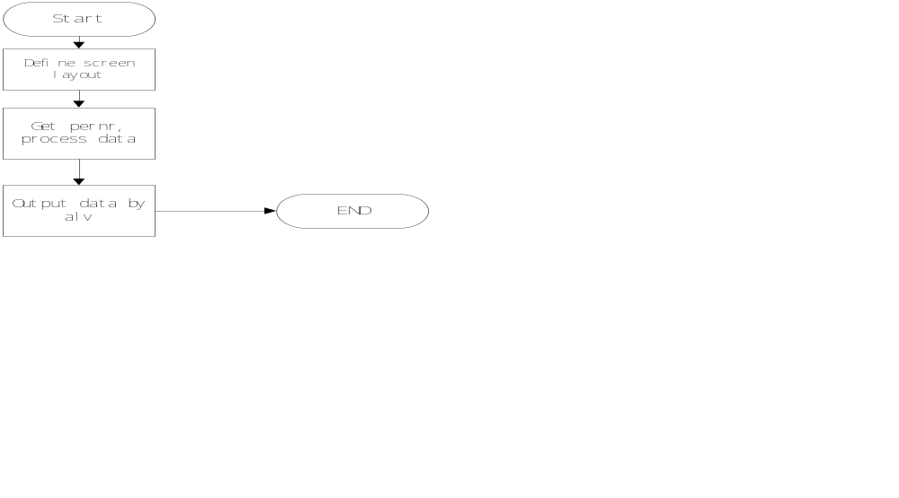

Data Processing and Transformations
*1.default screen layout
LOOP AT SCREEN.
IF screen-name = ''
OR screen-group4 = '119'
OR screen-group4 = '093'
OR screen-group4 = '095'
OR screen-group4 = '099'
OR screen-group4 = '101'
OR screen-group4 = '173'
OR screen-group4 = '176'
OR screen-group4 = '180'
OR screen-group4 = '122'
OR screen-group1 = 'PER'
OR screen-group4 = '184'.
screen-active = '0'.
MODIFY SCREEN.
ENDIF.

IF screen-group1 = 'ORG'.
screen-input = '1'.
screen-output = '1'.
screen-active = '1'.
screen-invisible = '0'.
MODIFY SCREEN.
ENDIF.
ENDLOOP.
IF pnpstat2[] IS INITIAL.
pnpstat2-sign = 'I'.
pnpstat2-option = 'EQ'.
pnpstat2-low = '3'.
APPEND pnpstat2.
ENDIF.
pnptimr1 = 'X'.
pnptimr6 = ''.
MOVE '@1F\QOrg. structure@ Org. structure' TO pnps$org.
IF pnptimr6 EQ 'X'.
pnpbegps = pnpbegda.
pnpendps = pnpendda.
pn-begps = pnpbegda.
pn-endps = pnpendda.
ELSE.
pnpbegps = sy-datum.
pnpendps = sy-datum.
ENDIF.

*2.get pernr, process data
*(1).get pernr
Get pernr.

IF NOT it_info_000[] IS INITIAL.
*(2).get hrp1000/9050

CLEAR:gt_result,gt_result[],g_orgeh,g_flag.
SELECT SINGLE stext FROM hrp1000 INTO gt_data-subdiv
WHERE objid EQ pernr-orgeh AND
begda LE pnpbegps AND
endda GE pnpendps.
CLEAR: gt_result,gt_result[],g_flag,g_orgeh,g_zzolv.
SELECT SINGLE zzolv INTO g_zzolv FROM hrp9050
WHERE objid EQ pernr-orgeh AND
zzolv EQ '04'.
IF NOT it_info_001[] IS INITIAL.
*(3).get structure
CALL FUNCTION 'RH_STRUC_GET'
EXPORTING
act_otype = 'O'
act_objid = g_orgeh
act_wegid = 'ZBOSS'
act_begda = pnpbegps
act_endda = pnpendps

TABLES
result_tab = gt_result
EXCEPTIONS
no_plvar_found = 1
no_entry_found = 2
OTHERS = 3
*(4).get pa0000/pa0182
SELECT SINGLE alnam INTO gt_data-alnam FROM pa0182
WHERE pernr EQ pernr-pernr AND
begda LE pnpbegps AND
endda GE pnpendps and
namtp EQ '3'.
select single begda into gt_data-hirda from pa0000
where pernr eq pernr-pernr and
( massn eq '01' or
massn eq '13' or
massn eq '30' ).

select single begda into gt_data-leada from pa0000
where pernr eq pernr-pernr and
( massn eq '10' or
massn eq '34')
and begda LE pnpendda
and begda GE pnpbegda.
.

*3.alv field
df_fieldcat 'DEPART' 'GT_DATA' 'Department' 'X' ' '.
df_fieldcat 'SUBDIV' 'GT_DATA' 'Subdivision' 'X' ' '.
df_fieldcat 'KOSTL' 'GT_DATA' 'Cost Center' 'X' ' '.
df_fieldcat 'ENAME' 'GT_DATA' 'Name(EN)' 'X' ' '.
df_fieldcat 'ALNAM' 'GT_DATA' 'Name(CH)' 'X' ' '.
df_fieldcat 'PERNR' 'GT_DATA' 'Staff code' 'X' ' '.
df_fieldcat 'STEXP' 'GT_DATA' 'Personal Title with function' ' ' ' '.
df_fieldcat 'PTEXT' 'GT_DATA' 'Category ' ' ' ' '.
df_fieldcat 'BEGDA' 'GT_DATA' 'Effective Date' ' ' ' '.
df_fieldcat 'STEXT' 'GT_DATA' 'Old department' ' ' ' '.
* df_fieldcat 'OEDAT' 'GT_DATA' 'Old Effective Date' ' ' ' '.
df_fieldcat 'QQMALE' 'GT_DATA' 'Gender' ' ' ' '.
df_fieldcat 'GBDAT' 'GT_DATA' 'Birthday' ' ' ' '.
df_fieldcat 'ZZPGD' 'GT_DATA' 'Grade' ' ' ' '.
df_fieldcat 'REPORT' 'GT_DATA' 'Reporting to' ' ' ' '.
df_fieldcat 'OZPGD' 'GT_DATA' 'Last Grade' ' ' ' '.
df_fieldcat 'HIRDA' 'GT_DATA' 'Hiring date' ' ' ' '.
df_fieldcat 'LEADA' 'GT_DATA' 'leaving date' ' ' ' '.

*4.alv layout.
CLEAR gs_layout.
gs_layout-cwidth_opt = 'X'.

*5. Output data on screen by alv
CALL FUNCTION 'REUSE_ALV_GRID_DISPLAY_LVC'
EXPORTING
i_callback_program = sy-repid
is_layout_lvc = gs_layout
it_fieldcat_lvc = gt_fieldcat[]
i_default = 'X'
i_save = 'A'
TABLES
t_outtab = gt_data
EXCEPTIONS
program_error = 1
OTHERS = 2

.

Screen Layout
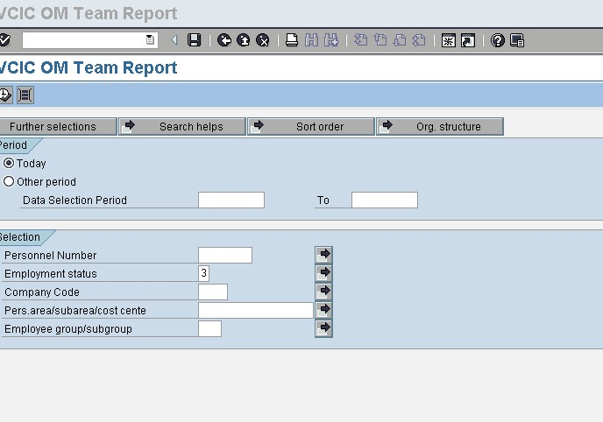

Report Layout
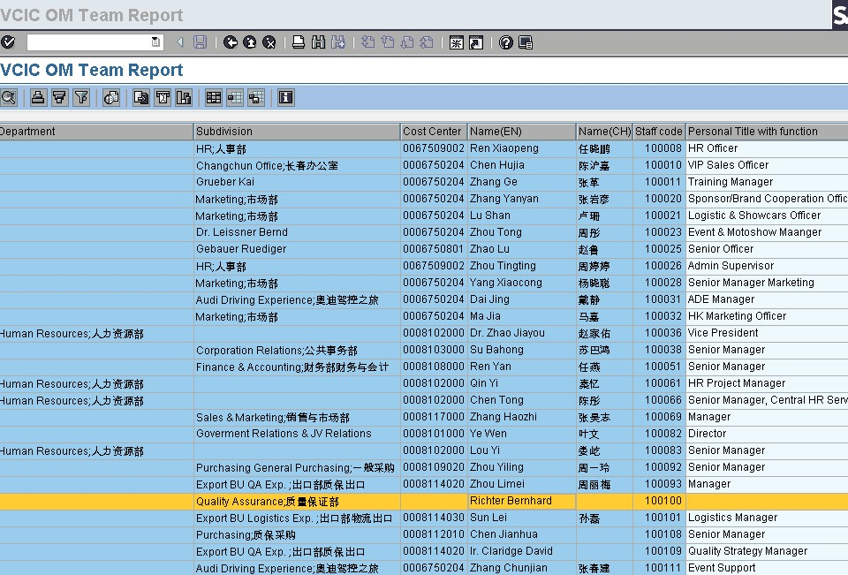

Exception Handling
n/a

Development object
Type | Name | Description
T-CODE | ZHR100 | VCIC OM Team Report
Name | ZHR_ORGTM_REPORT | VCIC OM Team Report

Data Dictionary Modification

List of New/Changed Data Dictionary Objects
No | Object Type  (Transparent table, program, view, etc.) | Status  (New, modified, deleted, etc.) | Object Name

Details of Data Dictionary Modifications

Internal table

*1. ALV

DATA: gt_fieldcat TYPE lvc_t_fcat,"slis_t_fieldcat_alv,
gt_exit TYPE slis_t_event_exit,g_name1 LIKE pa0001-ename,
g_name2 LIKE pa0182-alnam,
gs_exit TYPE slis_event_exit,
gs_layout TYPE lvc_s_layo,"slis_layout_alv,
gs_fieldcat TYPE lvc_s_fcat."slis_fieldcat_alv.

*2. Output data
DATA:BEGIN OF gt_data OCCURS 0,
depart LIKE hrp1000-stext,"Department
subdiv LIKE hrp1000-stext,"Subdivision
kostl LIKE pa0001-kostl,"Cost Center
ename LIKE pa0001-ename,"Name(EN)
alnam LIKE pa0182-alnam,"Name (CH)
pernr LIKE pa0001-pernr,"Staff code
plans LIKE pa0001-plans,"Personal Title with function
stexp LIKE hrp1000-stext,
ptext LIKE t501t-ptext," like TBD,"Category (GE,LE or Local)
begda LIKE pa0000-begda,"Effective Date (joining date)
stext LIKE hrp1000-stext,
oedat LIKE sy-datum,
gesch LIKE pa0000-begda,"Gender
qqmale(6),
gbdat LIKE pa0000-begda,"Birthday

* like TBD,"Personal
zzpgd LIKE zhrtgctp-zzpgd," Grade
report(110)," PA0001-ENAME +”/” + PA0182-ALNAM +”/” + PA0001-PERNR,"Reporting to
ozpgd LIKE zhrtgctp-zzpgd,"Last Grade,
hirda LIKE sy-datum,"Hiring date,
leada LIKE sy-datum,"leaving date.
END OF gt_data.

Messages
Message Class | Message ID | Message | Usage

Text Elements and Selection Texts
Field Name | Type | Obligate/Optional | Default Value | Description
Use PNP standard screen

Forms

n/a

Subroutines
Subroutine name | Description
check_screen_output | Default screen layout
frm_fill_eventcat_alv | Fill fields for alv
frm_fill_layout_alv | Alv layout
frm_start_list_viewer | Alv output

Interface/ALE/RFC Configuration
n/a

Workflow Configuration
n/a

